DATE: November 26, 2018

**Machine Learning PROJECT-Malware detection**

# Project Introduction

1. Project Link：https://tianchi.aliyun.com/getStart/introduction.htm?spm=5176.100066.0.0.518433af90bz1w&raceId=231694
2. After registering an account, you can register for the competition. The data can be downloaded from the website. Please refer to the website for details of the competition.

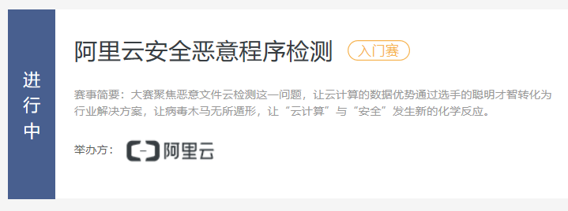

# Project performance evaluation and report code submission

The PROJECT results are composed of competition rankings, codes and reports.The report is written in English, including detailed intra-group division of labor, data processing and the model you use.Submit the code after the competition, which requires code comments and README.**The deadline for the project is December 21, 2018.**

Submission details: the submitted file is named ‘group leader name + student number. Zip’. The file content includes code, report and screenshot of grade ranking.

# Project Team

This PROJECT will be organized as a team. Each team shall have no more than three members. After the team is organized, the team leader shall prepare the account name, name and student number of the team members into TXT files and send them to the email address of ‘助教_z’ privately before December 3, 2018.E-mail: 17745161809 @163.com.

**Note:** since the competition is in the form of individual competition, **please submit the highest score of the members of the group as the final score**. The account name shall be the final account name at the time of submission and shall be consistent with the score in the screenshot.Naming rules: **XXX_ the last four digits of the student number**, XXX can be named at will.Account name must be strictly defined in accordance with the rules, otherwise it will not be counted as a result.